Imperial Journal of Interdisciplinary Research (IJIR)
Vol-2, Issue-6, 2016
ISSN: 2454-1362, http://www.onlinejournal.in

Social Networking Website for College: A Social Website Based Approach
Kaustubh Jagasia¹, Parimal Aglawe² & Arthi C.I.³
^{1,2}(B.E.) CMPN, VESIT.
³Assistant Professor, CMPN, VESIT

Abstract: This paper discusses about the project implementation of social networking site for teaching and learning purposes. The type of social space available to users can provide a more personalized and interactive experience for educative purpose. The growing demand of engineers in the industry makes it very important for the students to know about the practical use of technologies that are taught in the college and also to know about the latest technology and projects that the industry works with. Thus, a platform where students can interact with the industry professionals would prove to be a great benefit for them. In this project a social networking site exclusive for the college has been created whereby students, faculty and selective people from the industry would be able to socialize and share their knowledge. Also it would be a hub to share information about all the ongoing activities in the college campus. This paper describes the features implemented in this project and presents a glimpse of how the website works.

Keywords - VESIT ( Vivekanand Education Society’s Institute of Technology) , SNS ( Social Networking Site ) , privacy, wall, account.

1. Introduction

segregated and each category of user will have its own privileged tasks. A hierarchy of these categories of users is created such as The Principal, Industry professionals, General Staff, Passed out alumni, Current Students ( in descending order ) where. This hierarchy is designed in Bell Lapadula Configuration. . It is very inconvenient for teachers to find students’ parent contact information, our website will have an exclusive option for teachers to find parent’s contact details with a click of button. All campus students when registering will compulsorily need to fill their parent’s contact details so that it becomes easy for teachers to contact them when needed. Also taking into account the fact that parent’s contact information is something which is too personal for a student this social networking site will not be allowing a particular student to view other student’s parent contact details as it can be misused. Similarly, students would not be able to view all the personal details of faculty or industry people. They’ll be only allowed to view the details which are relevant to them from academic or professional point of view. They’ll be able to view the research conducted by teachers, their department and subjects etc. It will promote teaching and learning through a more dynamic platform without causing any threat to privacy.

We know about the increasing use of social | 2. Literature Survey
networking sites, people use various social media | 2. Literature Survey
platforms depending on their requirements and | 2.1. Comparison of various social
interest. Social media is a dynamic platform that | 2.1. Comparison of various social
interest. Social media is a dynamic platform that | networking sites
can be used in so many ways to share news, | networking sites
knowledge, entertainment etc. In this project a | We have gone through the features of various
social media platform for college campus has been | social networking sites and made a list of some
created where everyone associated with the college | basic functions which are or are not available in
campus such as students, staff members, associated | these sites. This analysis helped us to understand
industry professionals and passed out alumni can | which social media we can refer to in order to add
socialize with each other and share their knowledge | our desired features. The following table provides
about academics, projects, placements and all other | an overall summary for some of the most popular
activities going on in the campus. The functions of | sites.
various categories of users are going to be
Imperial Journal of Interdisciplinary Research (IJIR) | Page 298

Imperial Journal of Interdisciplinary Research (IJIR)
Vol-2, Issue-6, 2016
ISSN: 2454-1362, http://www.onlinejournal.in

 |  |  |  | Table 1. Comparison study
 |  | Facebook |  | Twitter | Google+ | Myspace | LinkedIn
 | Description | Largest social |  | A platform where | Integrates | Focuses on | Focused on
 |  | network with |  | people get updates | Google buzz | music, art and | connecting
 |  | wide appeal |  | about | and Google | other | professionals
 |  |  |  | people/organisation | profiles | entertainment | with the
 |  |  |  | they find interesting |  |  | purpose of
 |  |  |  |  |  |  | sharing
 |  |  |  |  |  |  | information
 |  |  |  |  |  |  | and
 |  |  |  |  |  |  | opportunities
 | Privacy | Privacy |  | You can choose | Privacy | Users between | Privacy
 | settings | settings are |  | either public(default) | settings are | 13-15 are | settings are
 |  | highly |  | or private account | highly | automatically | highly
 |  | customizable, |  |  | customizable, | private | customizable,
 |  | allowing users |  |  | allowing users | accounts. | allowing users
 |  | to decide |  |  | to decide | Older users | to decide
 |  | which |  |  | which | can choose | which
 |  | information to |  |  | information to | private or | information to
 |  | share with |  |  | share with | public account | share with
 |  | which users |  |  | which users |  | which users
 | Website
 | widgets and
 | integration
 | Photo sharing
 | Video sharing |  |  |  |  | No, but Flash
 |  |  |  |  |  | can be
 |  |  |  |  |  | embedded
 | Chat features
 | Private
 | messaging
 | 2.2. Potential of social networking sites in |  |  |  | as “perspective taking”, and to fulfill the need for
 | education |  |  |  | social support, intimacy, autonomy, etc.
 | As this social networking site focuses on |  |  |  | 2.3. Comparison of faculty and student
 | collaborative teaching and learning, the above |  |  |  | usage of social networking sites
 | mentioned research has been done to come across |  |  |  | The above survey shows the usage of a social
 | the positive and negative impacts of SNSs which
 | formed the basis to assist us in regulating our SNS. |  |  |  | media platform by students and faculty members. It
 | In this research, it was found that Facebook started |  |  |  | was concluded that while a large percentage of
 | in the campus of Harvard University. Its usage was |  |  |  | students were active on Facebook, the teachers
 | exclusively designed for the members of the |  |  |  | comparatively showed a lesser percentage. The
 | campus. It expanded to include other educational |  |  |  | inference drawn was that faculty members prefer to
 | institutions such as schools, universities, colleges |  |  |  | use E- mail for educational purposes. Facebook
 | and organization. It was also noted that many |  |  |  | reveals all the personal details of a particular
 | librarians had joined Facebook for social reasons |  |  |  | person and has all the friends and family
 | but later on it was also used for promotion of |  |  |  | connections. This might be a reason behind the less
 | education and library related events. |  |  |  | usage by teachers for academic purposes. As this
 | To add to it, there are other psychosocial benefits |  |  |  | social networking site is confined to the college
 | of SNS such | as the facilitation of identity |  |  | campus activities, it will increase the likelihood of
 | exploration, facility of social cognitive skills such |  |  |  | usage by the faculty members. This is the major
 |  |  |  |  |  |  | Page 299
 | Imperial Journal of Interdisciplinary Research (IJIR) |  |  |  |  |  | Page 299


Imperial Journal of Interdisciplinary Research (IJIR)
Vol-2, Issue-6, 2016
ISSN: 2454-1362, http://www.onlinejournal.in

advantage of this project as it | will promote the | educational communications and collaborations.
students and faculty alike to | strengthen their

3. Design
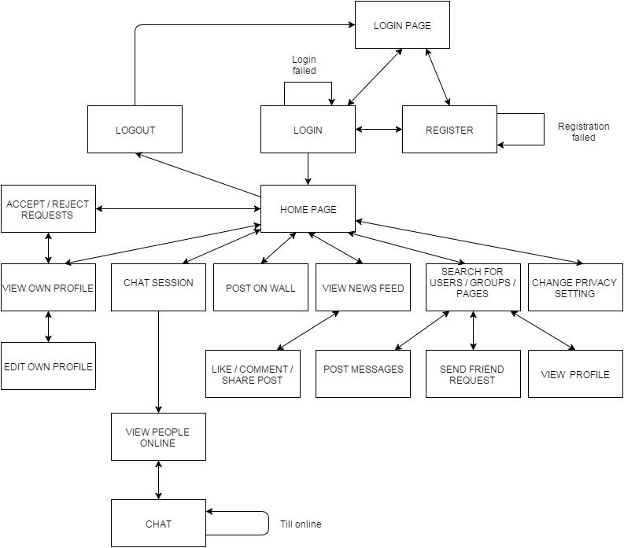

Fig 1. Block Diagram

Imperial Journal of Interdisciplinary Research (IJIR) Page 300
Imperial Journal of Interdisciplinary Research (IJIR)
Vol-2, Issue-6, 2016
ISSN: 2454-1362, http://www.onlinejournal.in
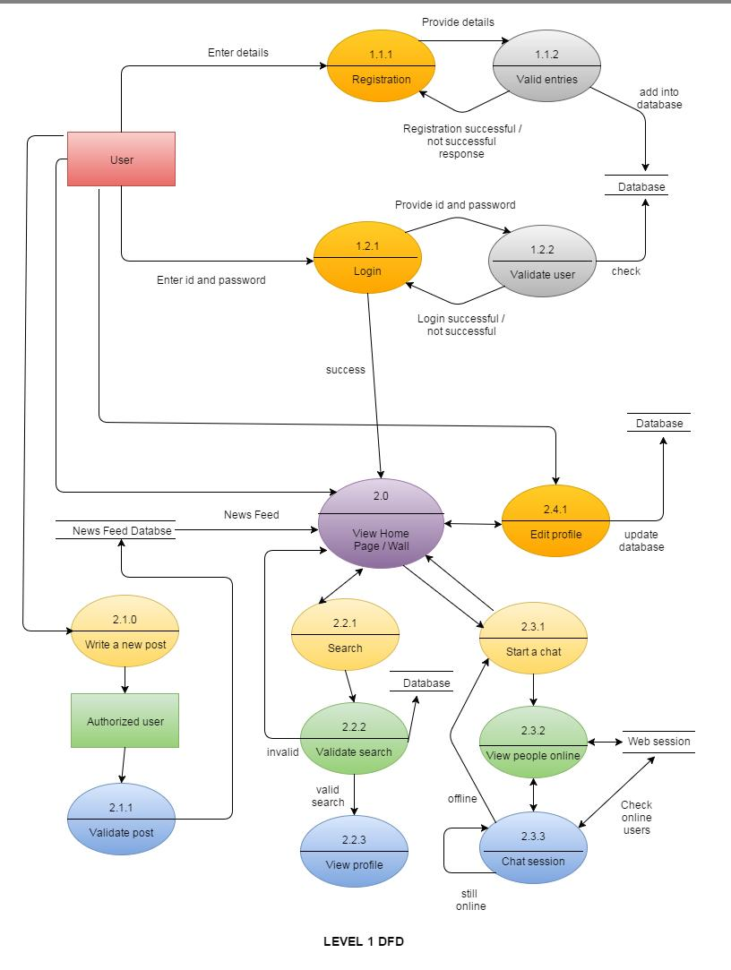

Fig 2. Level 1 Data Flow Diagram | Page 301
Imperial Journal of Interdisciplinary Research (IJIR) | Page 301

Imperial Journal of Interdisciplinary Research (IJIR) Vol-2, Issue-6, 2016
ISSN: 2454-1362, http://www.onlinejournal.in

4. Implementation

4.1. home.php

This is the first page that would be displayed when a user opens the website. User will have two options: either to sign in if he/she is already a registered user or sign up if he/she is a first time user. In case of invalid username or password, the

user will be informed about the invalid input and asked to enter it again. Similarly, unless and until a new user does not enters all the required details, he/she won’t be able to create his/her account.

Sample screenshot :

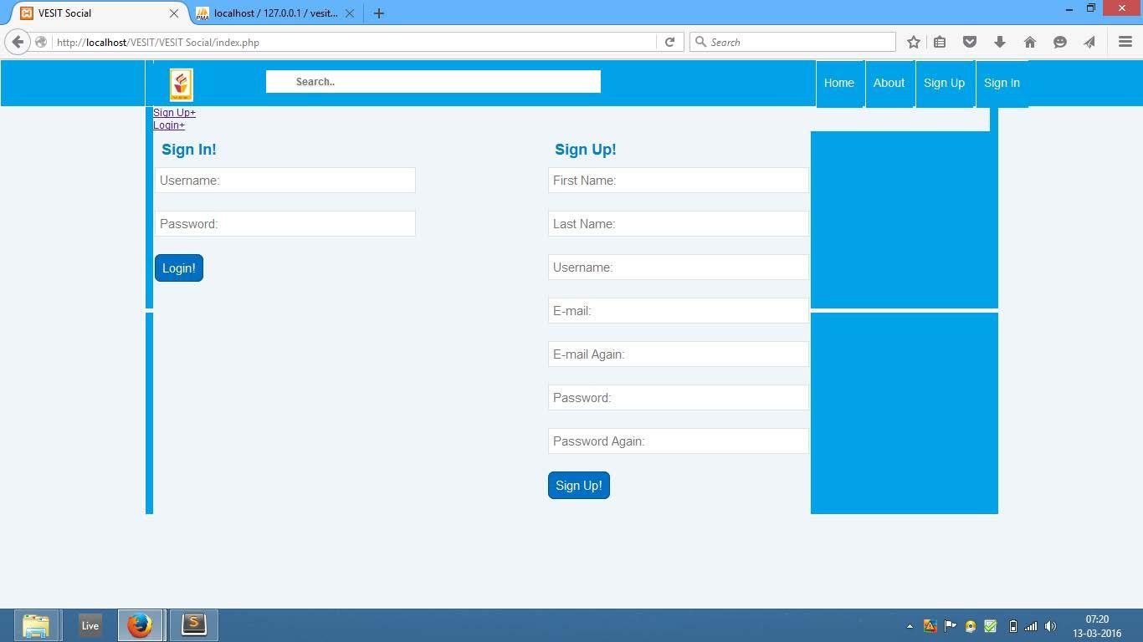

4.2. send_post.php

The wall page is the place where students and teachers would be able to post the information they want to. As soon as any information is posted, it will be visible to all other users who are within a user’s friend list. The news will be visible on

screen in the descending order of their post time so the latest information will be displayed first. This will ensure that all the current and forthcoming college activities are immediately visible to users.

Imperial Journal of Interdisciplinary Research (IJIR) Page 302

Imperial Journal of Interdisciplinary Research (IJIR)
Vol-2, Issue-6, 2016
ISSN: 2454-1362, http://www.onlinejournal.in

Sample Screenshot:
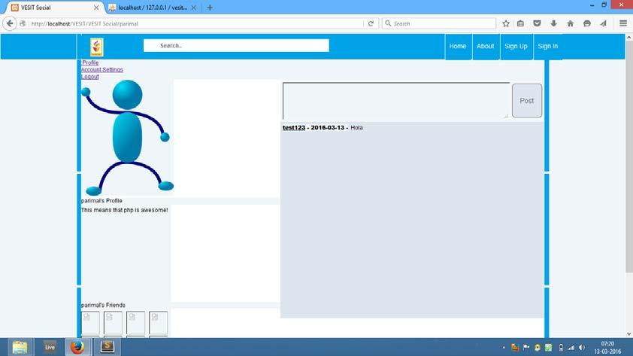

4.3. account_settings.php

This page allows user to change his/her account settings whereby the user would be given an option to change his/her password and update their profiles.

Sample Screenshot:
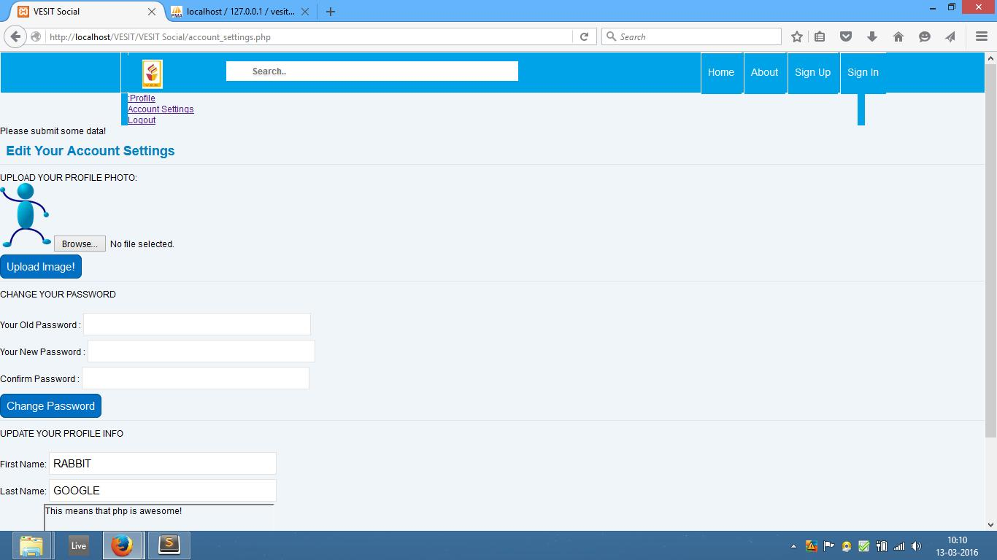

Imperial Journal of Interdisciplinary Research (IJIR) Page 303
Imperial Journal of Interdisciplinary Research (IJIR)
Vol-2, Issue-6, 2016
ISSN: 2454-1362, http://www.onlinejournal.in

- Testing

  - Login module : Following test cases were considered to ensure the working of login module

 |  |  |  |  |  | Table 2. Login test case
Test case id |  | Test case |  |  |  |  |  | Expected |  |  |  |  | Actual output |  |  |  | Test case result
 |  |  |  |  |  |  |  | output
1. |  | Valid | username |  | valid |  |  | Login success |  |  |  |  | Login success |  |  |  | Pass
 |  | password
2. |  | Valid username |  |  | invalid |  |  | Login failure |  |  |  |  | Login failure |  |  |  | Pass
 |  | password
3. |  | Invalid | username valid |  |  |  |  | Login failure |  |  |  |  | Login failure |  |  |  | Pass
 |  | password
4. |  | Invalid |  | username |  |  |  | Login failure |  |  |  |  | Login failure |  |  |  | Pass
 |  | invalid password
2. Search module : Following test cases were considered to ensure the working of search module
 |  |  |  |  | Table 3. Search test case
Test case id |  | Test case |  |  |  |  | Expected output |  |  |  |  |  | Actual output |  |  |  |  |  | Test case result
1. |  | Searching |  |  | valid |  | Redirect |  |  | to | the |  | Redirect |  | to |  | the |  | Pass
 |  | profile/page |  |  |  |  | requested page |  |  |  |  |  | requested page
2. |  | Searching |  | invalid |  |  | “No |  | such |  | page |  | “No | such |  | page |  |  | Pass
 |  | profile/page |  |  |  |  | found” message |  |  |  |  |  | found” message

3. Further, testing was conducted to check for the | encrypted MD5 format and thus password security
entries/retrieval of data into/from the database. | is ensured. News feed and messaging options were
Passwords stored in the database table were in the | tested and found to work in expected condition.
6. Conclusion | would be able to connect and share their
By creating this website for college, it is aimed to | knowledge with each other. Also efforts can be
By creating this website for college, it is aimed to | taken to incorporate links to various journals which
strengthen the communication among users and | students and teachers can use to publish their
make campus life more lively and exciting by | papers and also get an access to other research
combining academics and cultural activities. This | papers. An android application can be developed as
social media platform will become an asset for the | well which would enable users to access this social
campus and can be used for various productive | media through their mobile devices.
purposes. This social networking site can be further
expanded to all the engineering colleges in the city | Page 304
whereby all engineering students and faculties | Page 304
Imperial Journal of Interdisciplinary Research (IJIR) | Page 304

Imperial Journal of Interdisciplinary Research (IJIR) Vol-2, Issue-6, 2016
ISSN: 2454-1362, http://www.onlinejournal.in

7. Acknowledgement

We are thankful to our college Vivekanand Education Society’s Institute of Technology for considering our project and extending help at all stages needed during our work of collecting information regarding the project.
It gives us immense pleasure to express our deep and sincere gratitude to Assistant Professor Arthi C.I. (Project Guide) for her kind help and valuable advice during the development of project synopsis and for her guidance and suggestions.

We are deeply indebted to Head of the Computer Department Dr.(Mrs.)Nupur Giri Ma’am and our Principal Dr. (Mrs.) J.M. Nair Ma’am, for giving us this valuable opportunity to do this project. We express our hearty thanks to them for their assistance without which it would have been difficult in finishing this project synopsis and project review successfully.
We convey our deep sense of gratitude to all teaching and non-teaching staff for their constant encouragement, support and selfless help throughout the project work. It is great pleasure to acknowledge the help and suggestion, which we received from the Department of Computer Engineering. We wish to express our profound thanks to all those who helped us in gathering information about the project. Our families too have provided moral support and encouragement at several times.

[5] http://www.w3schools.com/php/php_intro.asp [6]h ttp://www.w3schools.com/php/php_mysql_intro.asp [7] http://www.w3schools.com/php/php_ajax_php.asp

[8] http://www.slideshare.net/search/slideshow?searchfrom= header&q=social+networking+site

8. References

[1] https://www.pinterest.com/pin/97249673173266393/ [p1]

[2] Griffith, S., & Liyanage, L. (2008, June). An introduction to the potential of social networking sites in education. In Emerging Technologies Conference 2008

(p. 9).[p2] Retrieved From

http://ro.uow.edu.au/cgi/viewcontent.cgi?article=1008&c ontext=etc08

[3] Tenzin Tendar . (April 09, 2014) . Netlink - social networking site. www.slideshare.net .[p3] Retrieved from

http://www.slideshare.net/the10dar/document-

33319174
[4] Roblyer, M., McDaniel, M., Webb, M., Herman, J., &
Witty, J. V. (2010). Findings on Facebook in higher
education: A comparison of college faculty and student
uses and perceptions of social networking sites. The
Internet and Higher Education, 13(3), 134-140.[p4]
Retrieved from
http://www.sciencedirect.com/science/article/pii/S10967
51610000278 | Page 305
Imperial Journal of Interdisciplinary Research (IJIR) | Page 305

